Steps to add SSIS packages to SQL Server 2016

The following outline is for the 16 steps needed to manually import the DTS/SSIS Profiles packages to sql server 2016.

Step 1: Expand the server dropdown and right click over Integration Services and select, “Create Catalog.”



The name of the catalog database is defaulted to SSISDB, you will need to supply a password to encrypt the data transmission. Once you have entered the password press the Ok button. 

Now that you have created the SSIDB catalog, right click over the catalog and select “Create Folder”



A create folder screen will display that requires you supply the name of the folder. Name the folder “Profiles” and press OK at the bottom of the screen.



Once you have pressed OK, expand the Profiles folder by pressing the ‘+’ icon, right click and select “Import Packages”

Follow the next 5 steps in the wizard process to convert the dtsx files for import into the SSISDB.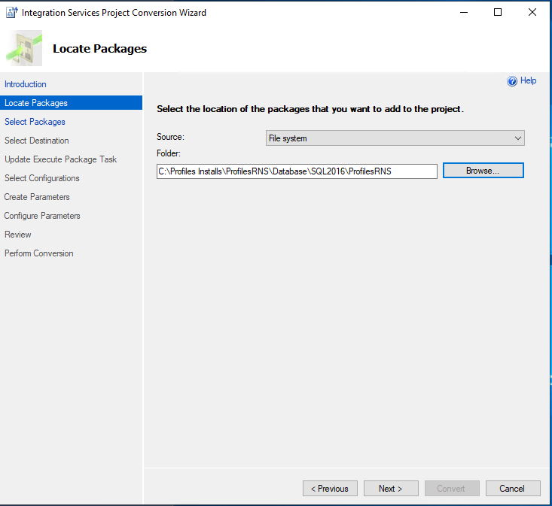

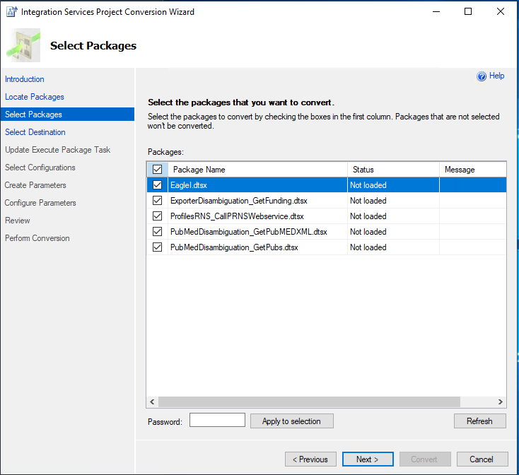

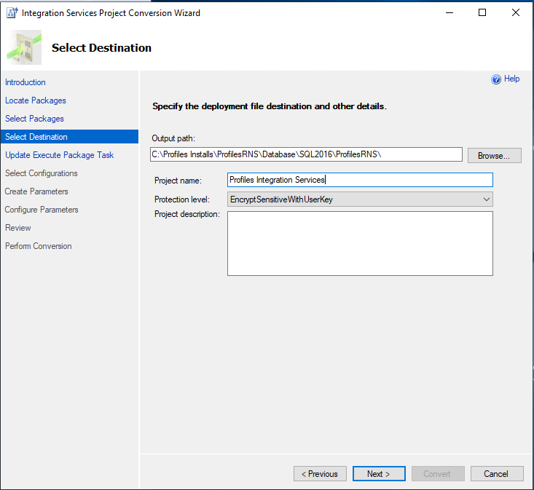

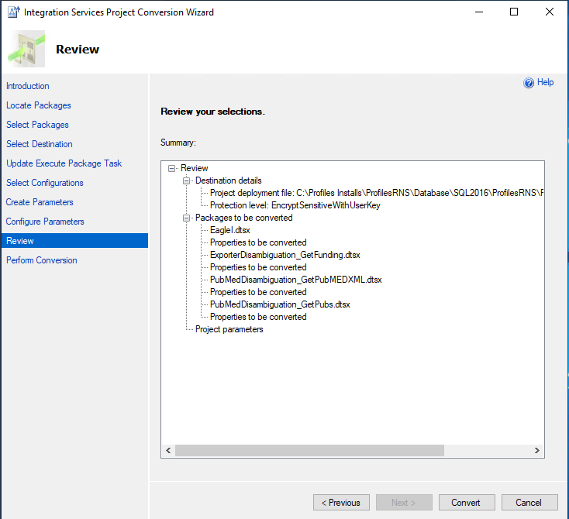

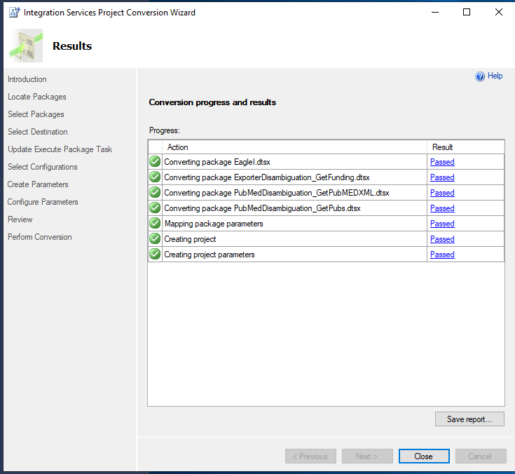

Once you close the conversion wizard, SQL server will automatically start the deployment process wizard. Leave the default setting for SSIS in SQL Server then press next.

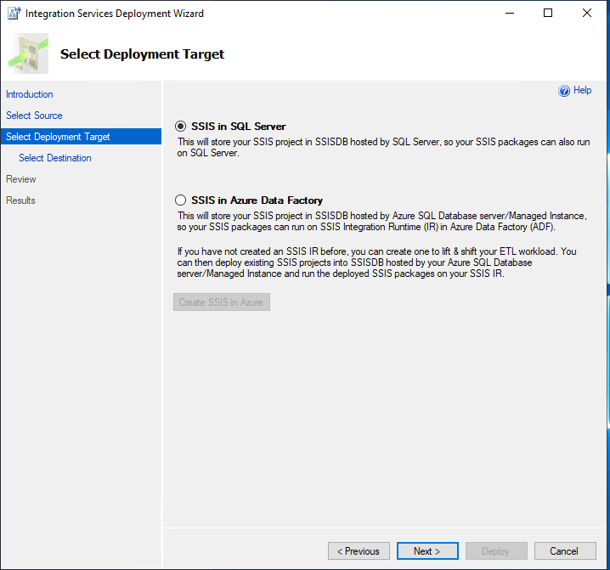

Make sure you manually press the Connect button to enable the Next button below.



Press Deploy

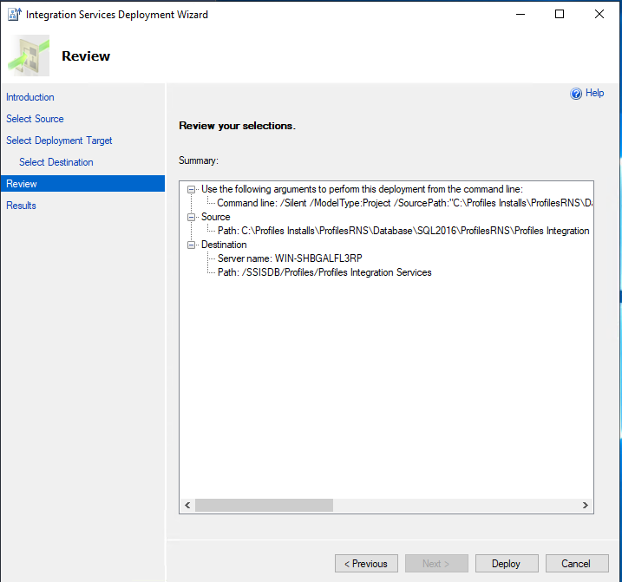

Review the results then press close.

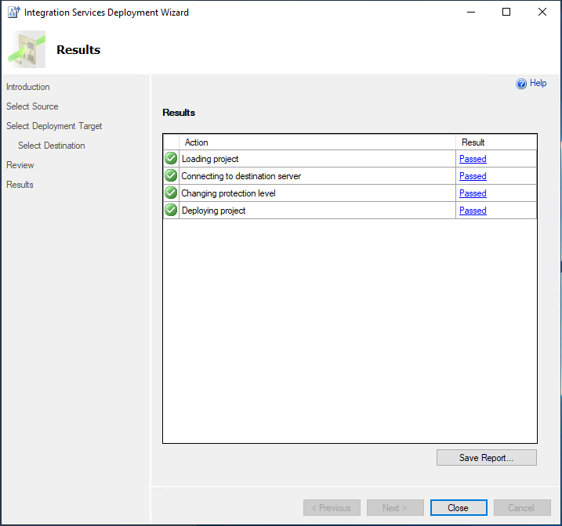

Refresh the SSISDB\Profiles folder and you will see the deployed packages.

